**Supplementary Materials**

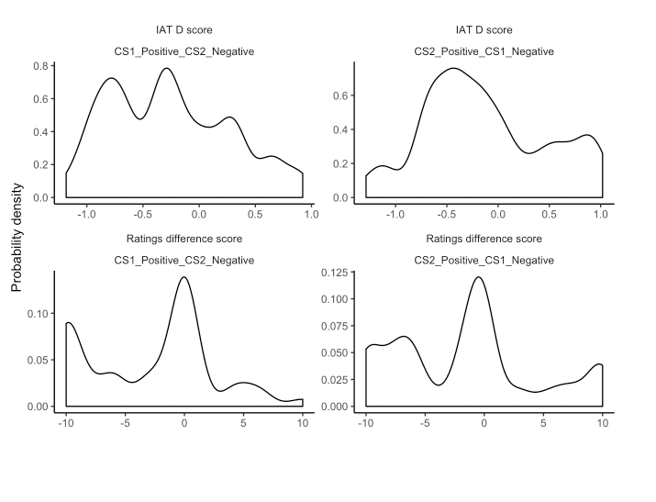

*Figure 6*. Distribution of automatic (upper panels) and self-reported (lower panels) evaluations for those in Experiment 2.

Table XX. *Percent of sample that meets the exclusion criteria.*

| **Experiment** | **US contingency aware** | **Color-valence contingency aware** | **Not demand compliant** | **Not influence awareness** | **Not hypothesis awareness** |
| --- | --- | --- | --- | --- | --- |
| 1 | 65.0 | 71.8 | 72.8 | 47.6 | 28.2 |
| 2 | 65.0 | 62.1 | 81.6 | 54.4 | 18.4 |
| 3 | 79.4 | 79.4 | 70.1 | 55.7 | 08.2 |
| 4 | 78.1 | 62.0 | 80.2 | 42.8 | 32.6 |
| 5 | 74.9 | 45.3 | 69.8 | 55.3 | 14.0 |
| 6 | - | - | 91.3 | 48.5 | 32.9 |
| 7 | 78.2 | 56.7 | 82.5 | 44.8 | 34.7 |
| 8 | 94.9 | - | 86.2 | 39.9 | 14.5 |

Table XX. *Moderation of the effect*

|  |  |  |  |  |  |  |  |
| --- | --- | --- | --- | --- | --- | --- | --- |
|  |  |  |  | |  | 95% CI | |
| DV | Moderator | Excluded subset | χ2 (*df* = 1) | *p* | Δ Effect Size | Lower | Upper |
| *IAT* | |  |  |  |  |  |  |
|  | US contingency | aware | 0.01 | .903 | *d* = 0.03 | -0.48 | 0.54 |
|  | Color-valence contingency | aware | 2.45 | .118 | *d* = -0.76 | -1.72 | 0.19 |
|  | Demand compliance | non-compliant | 0.01 | .929 | *d* = 0.04 | -0.77 | 0.84 |
|  | Hypothesis awareness | unaware | 5.34 | .021 | *d* = 0.73 | 0.11 | 1.35 |
|  | Influence awareness | unaware | 13.27 | < .001 | *d* = 0.81 | 0.37 | 1.24 |
| *Self-reported evaluations* | |  |  |  |  |  |  |
|  | US contingency | aware | 0.46 | .497 | *d* = 0.11 | -0.21 | 0.43 |
|  | Color-valence contingency | aware | 11.26 | < .001 | *d* = -1.47 | -2.33 | -0.61 |
|  | Demand compliance | non-compliant | 10.58 | .001 | *d* = 0.80 | 0.32 | 1.28 |
|  | Hypothesis awareness | unaware | 20.46 | < .001 | *d* = 1.39 | 0.79 | 2.00 |
|  | Influence awareness | unaware | 10.18 | .001 | *d* = 1.13 | 0.44 | 1.83 |
| *Behavioural intentions* | |  |  |  |  |  |  |
|  | US contingency | aware | 4.60 | .032 | OR = -0.87 | -1.67 | -0.07 |
|  | Color-valence contingency | aware | 19.39 | < .001 | OR = -3.02 | -4.36 | -1.67 |
|  | Hypothesis awareness | unaware | 39.94 | < .001 | OR = 2.87 | 1.98 | 3.76 |
|  | Influence awareness | unaware | 38.41 | < .001 | OR = 2.83 | 1.94 | 3.73 |
| *Notes:* Excluded subset = subset of participants that was excluded for the robustness tests; Δ Effect Size = Change in meta effect size in the subset excluded by the robustness tests relative to the included subset. | | | | | | | |